MINISTRY OF SCIENCE AND EDUCATION NATIONAL TECHNICAL UNIVERSITY “KHARKIV POLYTECHNIC INSTITUTE”

DEPARTMENT OF SOFTWARE ENGINEERING AND MANAGEMENT INFORMATION TECHNOLOGIES

Report from lab#1

Discipline “Fundamentals of Software Engineering”

Executed by: Student of group KN-37zh

MOHAMMED AMINE BENHASSOUN

Checked by: Senior lecturer

K.V. Melnik

Kharkiv

2017

**Goal:** Learning Use Case and Activity Diagrams by using Visual paradigm

**Tasks:**

1. Get the task and analyze the computational algorithms.

2. Develop the Activity diagram.

3. Develop the Use Case diagram.

4. Prepare the report of the work

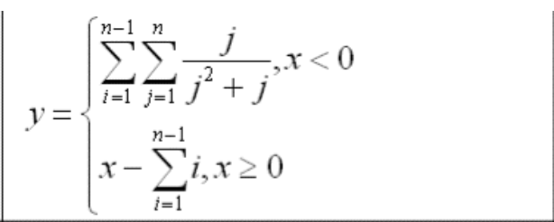

**Task #1**

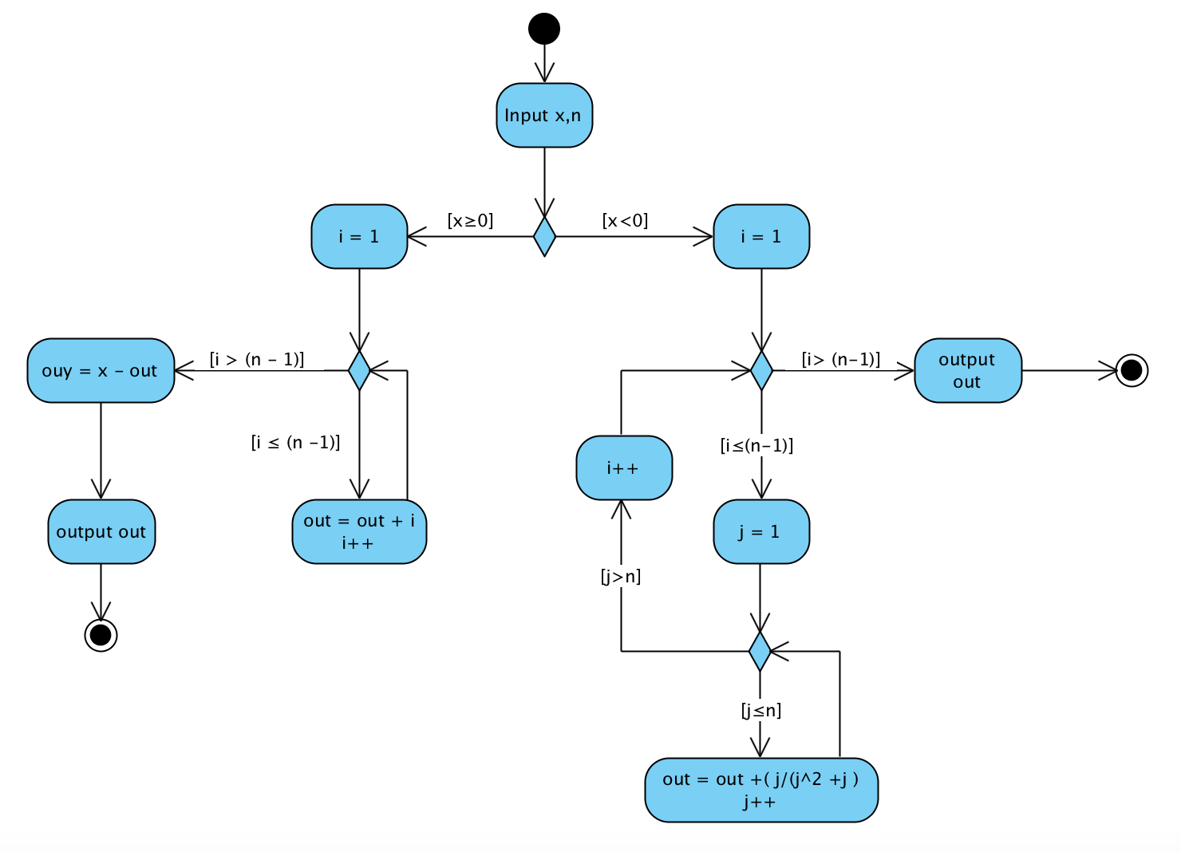

**Task #2**

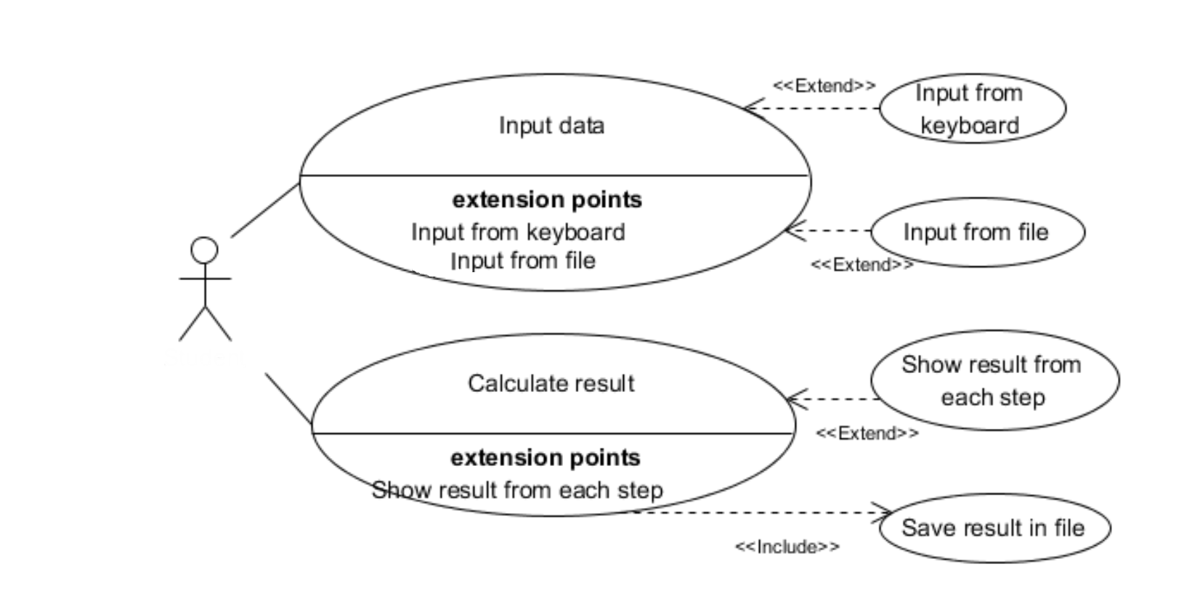

**Conclusion:**

During this lab, I learned how to develop the Activity diagram and the Use Case diagram by using Visual paradigm.